Caitlin Zaring Weir, Post Doctoral Research Associate, Department of Animal Science, University of Tennessee
Liz Eckelkamp, Associate Professor and State Dairy Extension Specialist, Department of Animal Science, University of Tennessee
This Excel workbook is designed to provide producers with helpful financial and processing information to support decisions about starting or expanding a bottled milk value-added dairy operation. This tool is intended to be used for investment planning considerations and should not be used for a day-to-day processing guideline.
Information needed to use the tool decision support tool:
- Milk production and milk quality: Yearly average herd size (not including youngstock and bulls), average production per cow per day, average fat and protein percentages, percentage of your raw milk you want to process.
- Products and packaging: Expected product percentages (such as whole, 2%, skim, etc.), packaging percentages (such as quarts, pints, gallons), and desired product sale price.
- Costs: Anticipated number of processing employees, hourly wage, hours worked per week, building facility costs, average utilities and other costs per year, current cost of production in CWT (if known), current mailbox milk price in CWT (if known), loan information (if available).
- Equipment: Desired or anticipated equipment (if you have quotes, use those).
To use this workbook, please follow the steps below. For more detailed instructions and screen captures, reference the subsequent pages.
- Make sure you enable external content/macros in Microsoft Excel.
- Click the “Start” button at the bottom of the “Instructions” sheet to bring you to the orange “Inputs” sheet.
- Fill in the grey-shaded cells – use or adjust the pre-filled data.
- Use the “Next” buttons to navigate through the green sheets: “Outputs,” “Suggested Equipment,” and “Equipment List.”
- Reference the personalized results and suggestions generated from your farm’s data.
The grey cells contain benchmark values generated from a comprehensive survey of Tennessee value-added dairies. These values can be modified to better fit your operation.
Note about security and usability: This file contains macros for navigation, calculations, and printing, which are essential for the tool to function properly. Microsoft Office may display warnings about enabling macros. Be sure to enable the macros in this file for functionality.
Note about “Can’t Autosave” warning: Click “Save As” and save the file with the auto populated file type (macro-enabled workbook [i.e. .xlsm]) on your computer.
Note for Mac users: This file contains macro-objects (pop-up windows) that may not work.
If you would like more information or have questions about this tool or the Southeast Dairy Business Innovation Initiative (SDBII), please reference www.sdbii.tennessee.edu or contact Liz Eckelkamp, University of Tennessee Extension, at eeckelka@utk.edu or at (865)-974-8167.
Getting Started
Below are guidelines on how each page should be used, including definitions and screen captures of each page.
Instructions Sheet
- This worksheet provides a general overview of the document, brief materials needed, a quick “how-to” with instructions on navigating the tool, and materials needed to utilize the tool correctly.
- You will see three black buttons towards the bottom of the Instructions sheet.
  - “Reset” button: Reset the values to the default values provided.
  - “Clear” button: Clear the data from the cells.
  - “Start” button: Begin the tool by directing you to the “Inputs” sheet.
- When you are ready to begin, click the “Start” button.
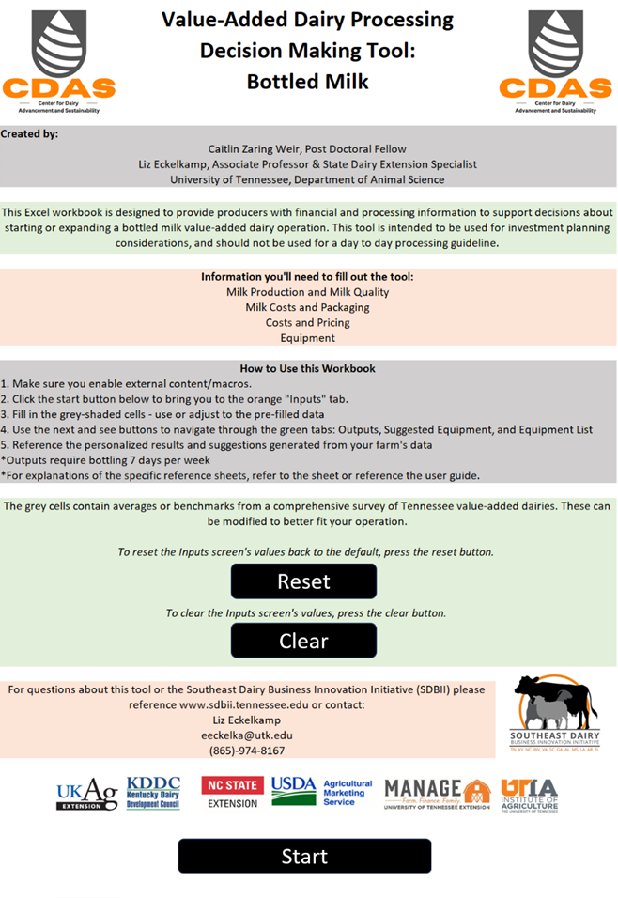
Step 1: Begin
Step 1: Begin
Inputs Sheet
- This worksheet is where you will enter all data associated with your farm and future processing facility into the grey cells.
- If you are unsure of what values to input, you can use the default values provided based on prior UTIA research.
- The black buttons will help you calculate values to enter into the grey cells or direct you to the next step.
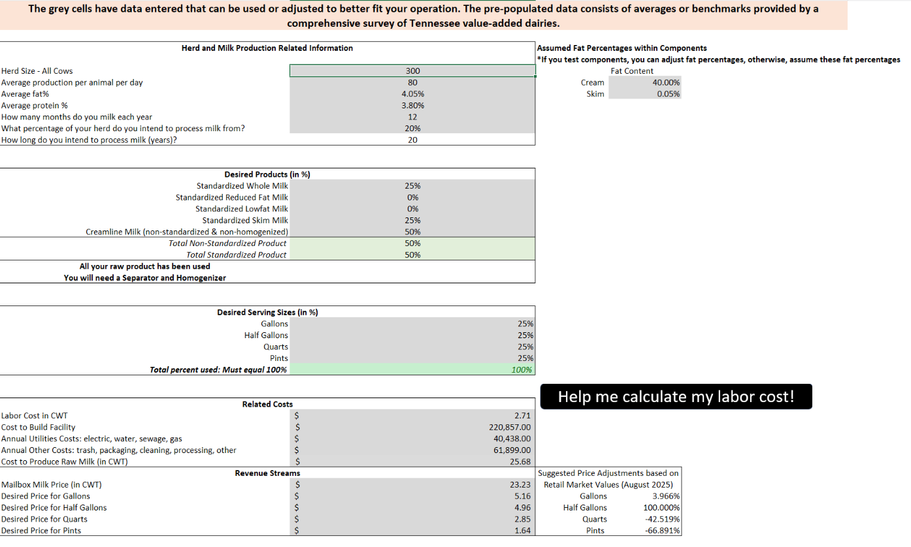
Step 2: Fill in Grey Cells
Step 3: Determine Labor Cost
Employee Cost Determining Pop-up Windows
- When you get to Cell B35 (Labor Cost in CWT), click “Help me calculate my labor cost!” This will initiate a pop-up window (see below).
- To begin, click “Add”, and the Employee Details screen will pop up. This is where you will enter the name (if desired), the hourly wage, and the hours worked per week.
Step 3A: Add
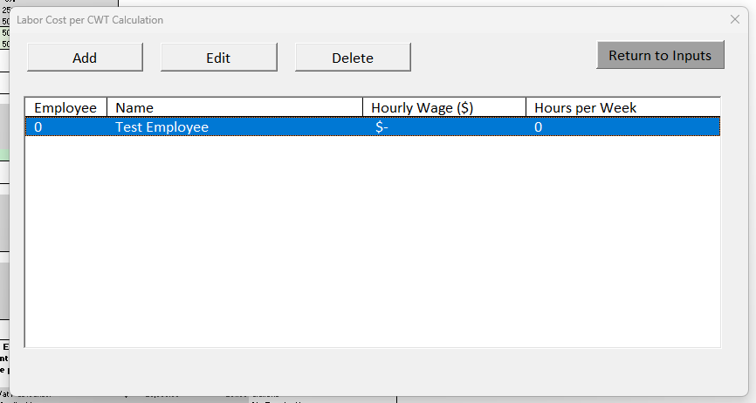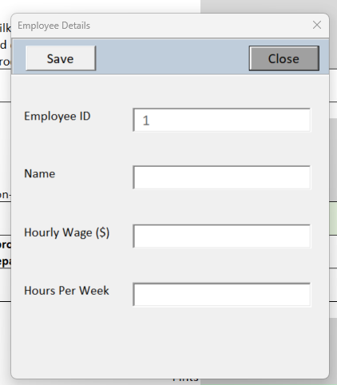
- Once you are ready to save the employee information, click “Save.” Then, accept the change with the “Save record” pop-up window.
- When you have finished adding employees, click close. This will return you to the main employee window and show your updated list of employees.
Step 3B: Save
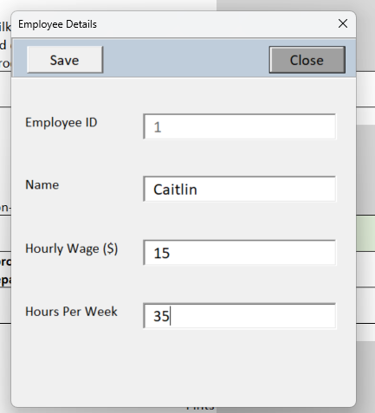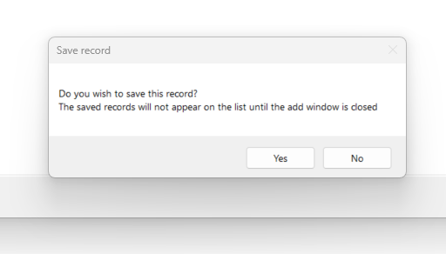
Step 3B: Save
- If you need to update an employee on the list, select the employee, then select “Edit.” When your changes have been made, select “Update,” then “Close.”
Step 3C:
Edit
Step 3C:
Edit

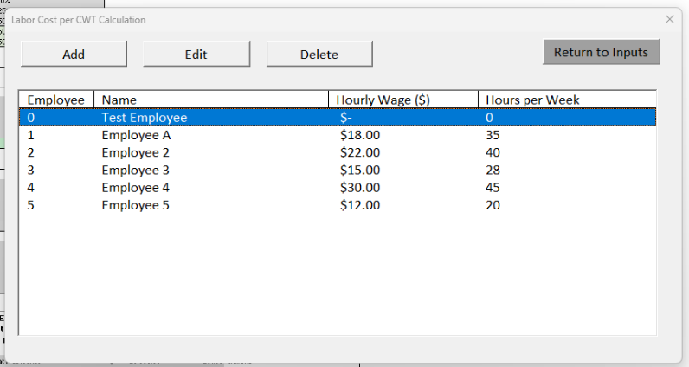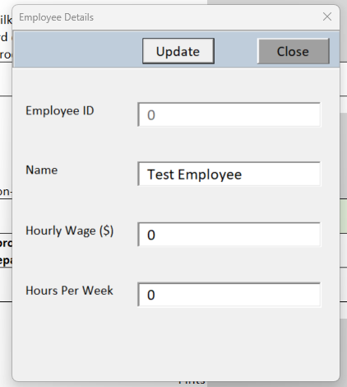
- When ready, select “Return to Inputs.” This will initiate a pop-up window that will show your labor cost per CWT. This number will be entered into cell C35, the cell to the right of the grey labor cost cell. Copy and paste this cell into the labor cost cell.
Step 3D: Return to Inputs
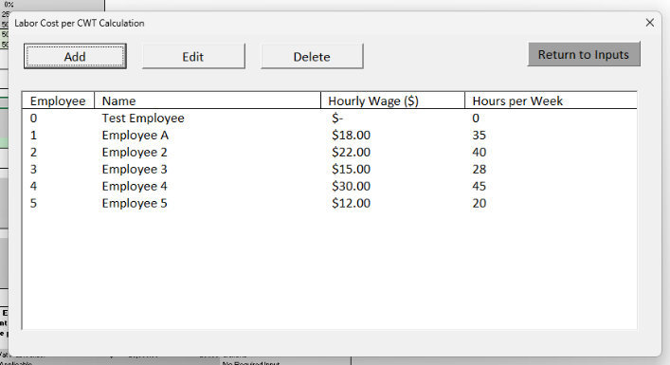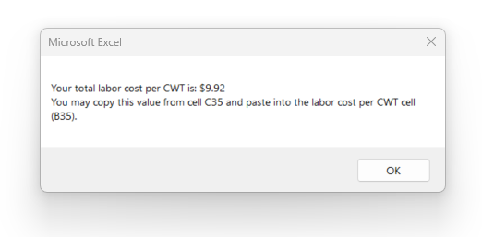
Step 3D: Return to Inputs
Step 3E: Enter Labor Cost per CWT & Continue
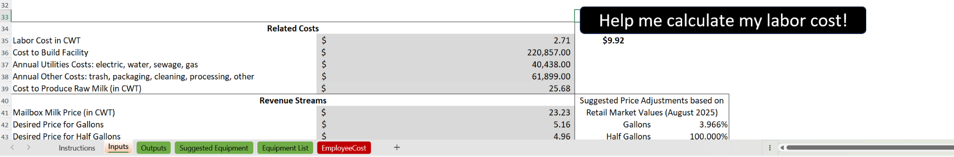
- Under Major Bottling Equipment Pieces, you can select which equipment you would like to use according to the dropdown menu. The price and capacity will be entered for all except the “Quoted” equipment options, which you will be required to enter.
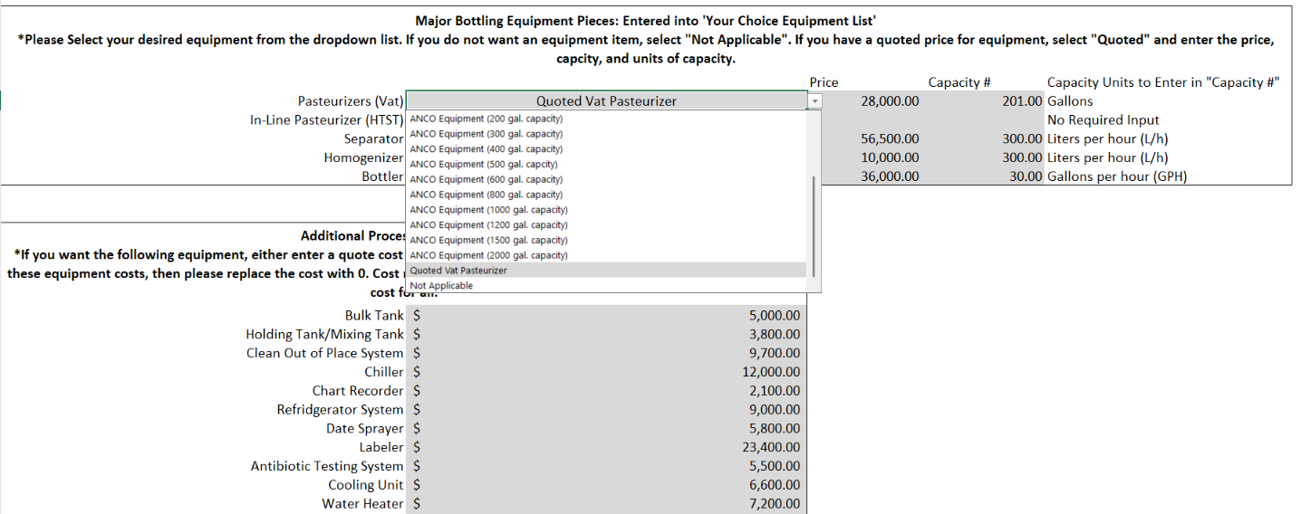
Step 4: Select Equipment

- When you are ready to proceed, you will select “Next Page” which will bring you to the outputs page where you can view your projected enterprise data.
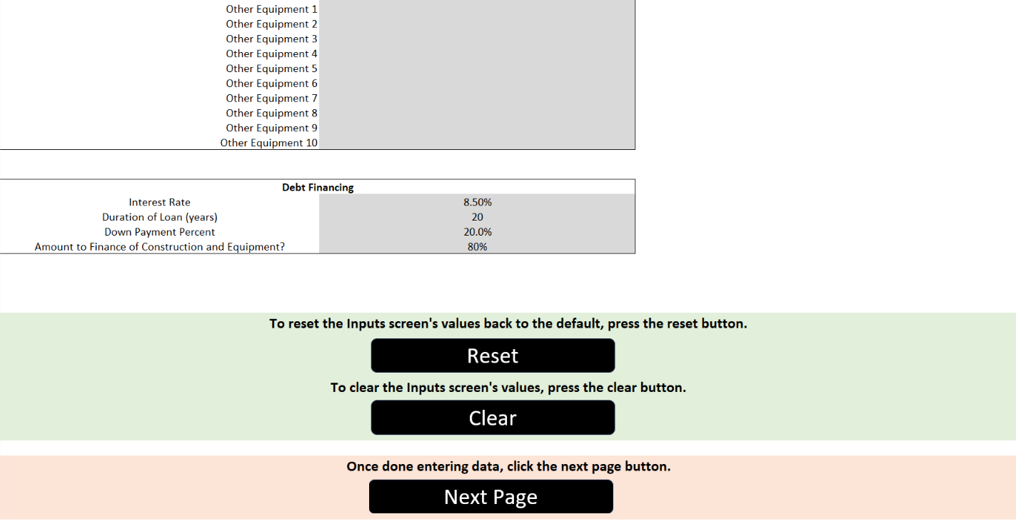
Step 5: View Results
Step 5: View Results
Step 1
Step 1

Outputs Sheet
- This worksheet provides you with an overview of the projected processing outputs based on the tool inputs. You will be able to view the milk types and quantities you selected, additional skim or cream that will be left over from bottling, and the quantity of bottled milk you will have in various packaging based on your selection.
- Various equipment selections will be provided for your use and the tool will show you the equipment pieces within each equipment option that limit your ability to grow your operation’s production capacity.
- A final statement will show you additional product revenue sources and a general overview of the operation.
- To see a detailed list of the equipment with suggestions, click “See ‘Suggested Equipment’” and “See ‘Equipment List’”.
- Make sure to export your personalized report as a PDF via the “Export to PDF” button. This button will allow you to choose a file name and location to save the file.
- When you have finished using the tool, or if you want to return to the beginning to re-run the tool under difference scenarios, click “Return to ‘Instructions’”.
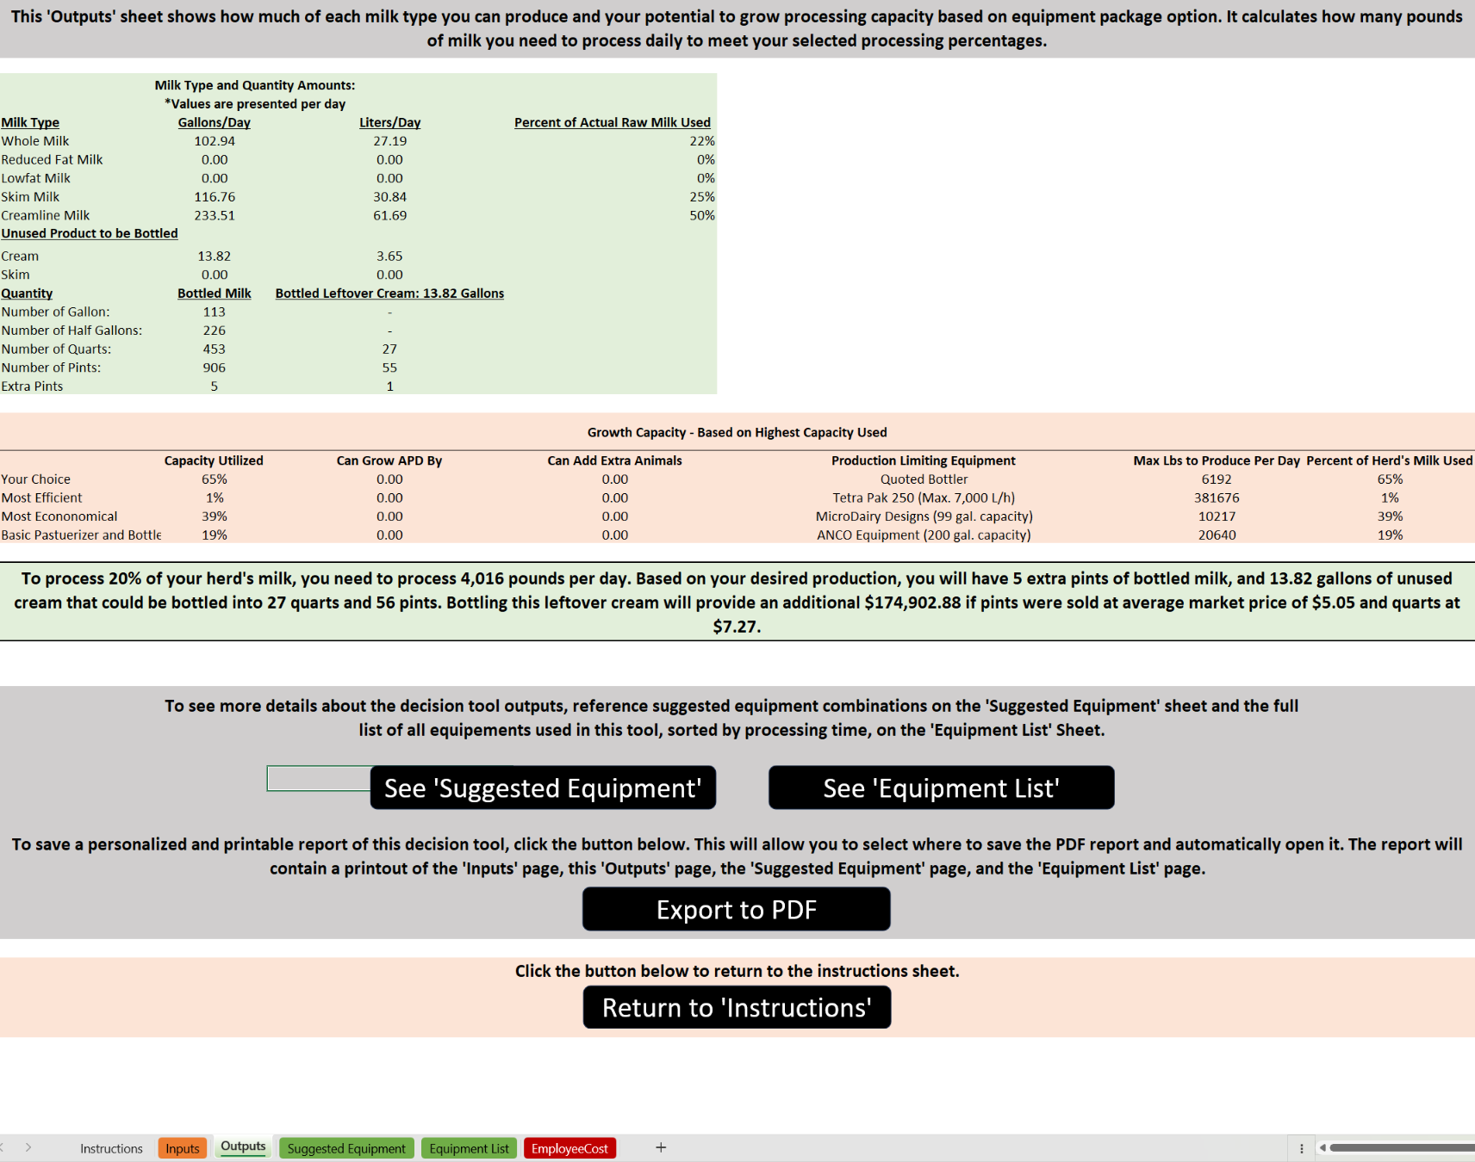
Make sure to export to PDF
Steps 6 & 7: See Equipment Options
Steps 6 & 7: See Equipment Options

Suggested Equipment Sheet
This worksheet provides various equipment combination suggestions. Each equipment combination has been defined below:
- Your Choice Equipment: This contains the equipment you selected on the inputs sheet.
- Most Efficient Suggestion: This contains the equipment combination that yields the fastest processing of one day’s worth of milk.
- Most Economical Suggestion: This contains the lowest cost equipment, while still requiring processing less than 10 hours per day, 7 days per week.
- Basic Pasteurizer/Bottler Suggestion: This option is most considered by first time bottlers, as it does not require a separator or homogenizer. This will produce full-fat creamline milk.
Each equipment suggestion listed above reports various economic outputs designed to inform grant applications and loan financiers. These outputs included:
- Years to Break Even: Number of years it will take to overcome the initial investment cost and begin to return a profit (known as payback period in SDBII grants).
- Net Present Value: The total value of the investment over time; how much more you would earn bottling milk versus not bottling.
- Internal Rate of Return: How fast your money is expected to grow with the investment in a bottled milk operation.
- Total Costs: Total cost of all equipment.
- Total Time: Total time required to process one day’s worth of raw milk.
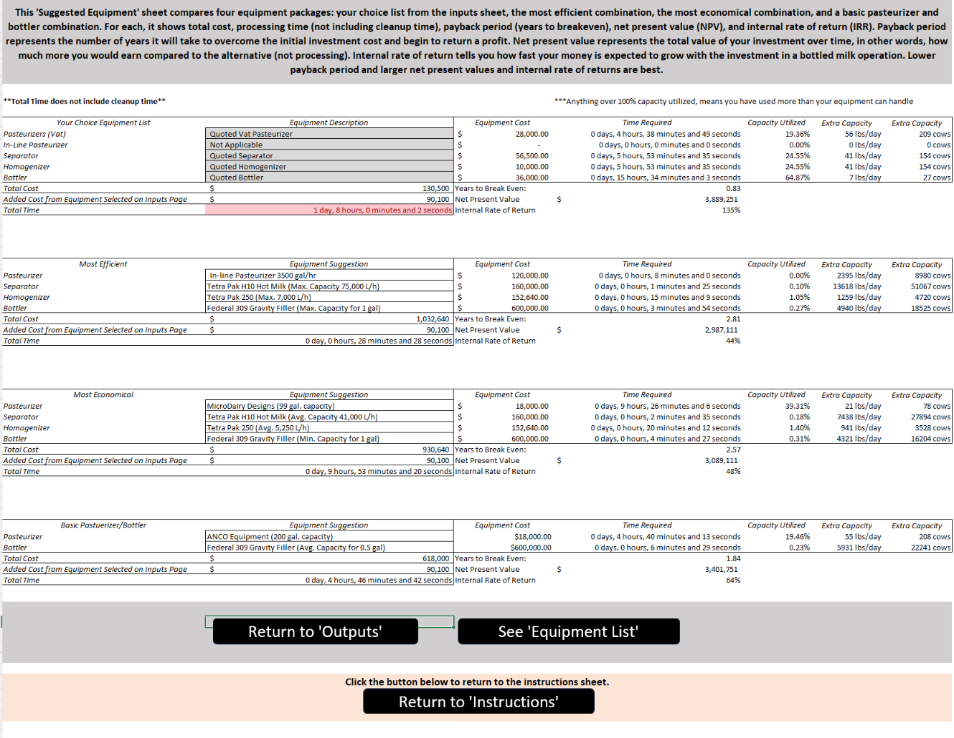
Steps 6 & 7: See Equipment Options
Equipment List Sheet
- This worksheet lists all equipment options that can be generated by the tool.
- Price estimates are from 2023 and are listed by category from shortest to longest run time.
- Each equipment line calculates the total run time based on your operation with the specific equipment piece corresponding to that line, the estimated cost based on prior quotes, the total equipment capacity used (number of pounds of bottled milk that can be processed), and based on that capacity utilized, how many more pounds could be processed, or how many animals could be added to maximize the equipment.
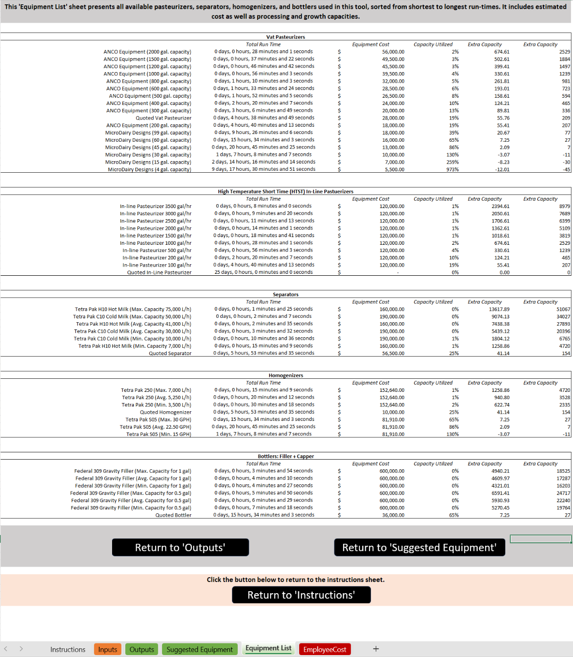
Finished? Wish to Retry the Model? Return to the “Instructions” and Clear/Reset the Data
Finished? Wish to Retry the Model? Return to the “Instructions” and Clear/Reset the Data

